Scrum master report

Iteration 1 (12/12/2016 – 18/12/2016)

Summary

Monday (12/12/2016) and Tuesday (13/12/2016), we discuss about the task allocation and how roughly how to do it and started on Wednesday (14/12/2016).

In the first iteration, the scrum team finished 5 user stories which have total 15 point. The user stories are mainly focus on the design of the webpage, user login, user registration, and user account management.

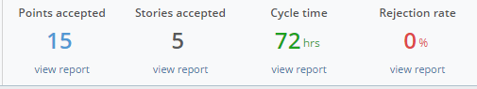

Iteration burnup

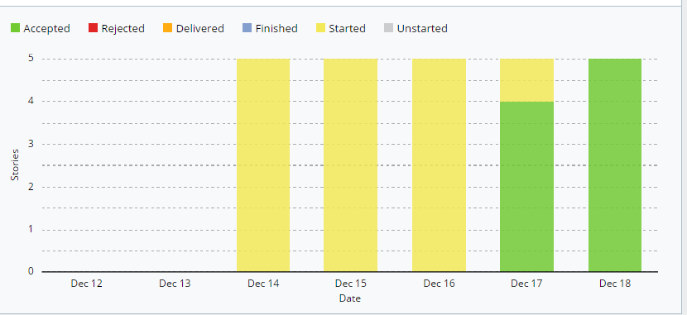

Backlog (Current)

|  |  |  |  |  |
| --- | --- | --- | --- | --- |
| User Story | Points | Date | | |
| Added | Started | Accepted |
| As a user, I want to have contact page and about page so that I can know more about the company and contact the admin if have any problem. | 3 | 14/12/16 | 14/12/16 | 17/12/16 |
| As a user, I want to have a menu that display all art gallery with category so that I can choose the gallery I want to. | 3 | 14/12/16 | 14/12/16 | 17/12/16 |
| As a user, I want the function that whenever I click on the art the information of the art will display so that I can know more about the gallery. | 3 | 14/12/16 | 14/12/16 | 17/12/16 |
| As a user, I want to register as a new member and log in to the account so that I can purchase online. | 3 | 14/12/16 | 14/12/16 | 17/12/16 |
| As a user, I want to have change password function so that I can change the password when I wanted to. | 3 | 14/12/16 | 14/12/16 | 18/12/16 |

Icebox

|  |  |  |  |  |
| --- | --- | --- | --- | --- |
| User Story | Points | Date | | |
| Added | Started | Accepted |
| As a user, I want to have add to cart function so that I can purchase multiple items at once. | 3 | 14/12/16 | - | - |
| As a user, I want to delete function in the cart so that I can remove the gallery that I don’t want to buy. | 3 | 14/12/16 | - | - |
| As a user, I want to purchase online so that I can buy the gallery through online. | 3 | 14/12/16 | - | - |
| As a user, I want to pay my order with different card so that I can confirm my purchase. | 3 | 14/12/16 | - | - |
| As a staff, I want to have a manage function so that I can upload new gallery to the website or delete it. | 3 | 14/12/16 | - | - |

Iteration 2 (19/12/2016 – 25/12/2016)

Summary

On Monday (19/12/2016) the scrum team had a meeting to discuss who in charge in which user stories. The team started to develop on Tuesday (20/12/2016) which one day after the discussion.

In this iteration, the scrum team finished 5 user stories which have total 15 point also. The second iteration user stories mainly focus on add to cart function (add and delete item from add to cart), payment function, and admin function (add new gallery and delete).

Since this was the last iteration so all the user stories had been completed and no more user stories in the ice box.

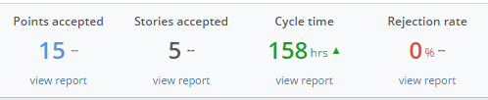

Iteration burnup

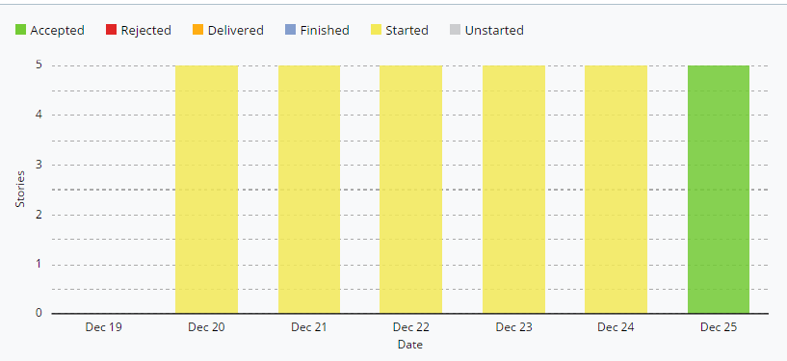

Backlog (Current)

|  |  |  |  |  |
| --- | --- | --- | --- | --- |
| User Story | Points | Date | | |
| Added | Started | Accepted |
| As a user, I want to have add to cart function so that I can purchase multiple items at once. | 3 | 14/12/16 | 20/12/16 | 25/12/16 |
| As a user, I want to delete function in the cart so that I can remove the gallery that I don’t want to buy. | 3 | 14/12/16 | 20/12/16 | 25/12/16 |
| As a user, I want to purchase online so that I can buy the gallery through online. | 3 | 14/12/16 | 20/12/16 | 25/12/16 |
| As a user, I want to pay my order with different card so that I can confirm my purchase. | 3 | 14/12/16 | 20/12/16 | 25/12/16 |
| As a staff, I want to have a manage function so that I can upload new gallery to the website or delete it. | 3 | 14/12/16 | 20/12/16 | 25/12/16 |